# Introduction

Main goal of rating testing toolkit is simplify rating attributes verification during testing automation. The rating attributes verification is process of comparing rating premiums and multipliers between rating engine that implemented by PAS development team and rating reference implementation that released by Design BA team.

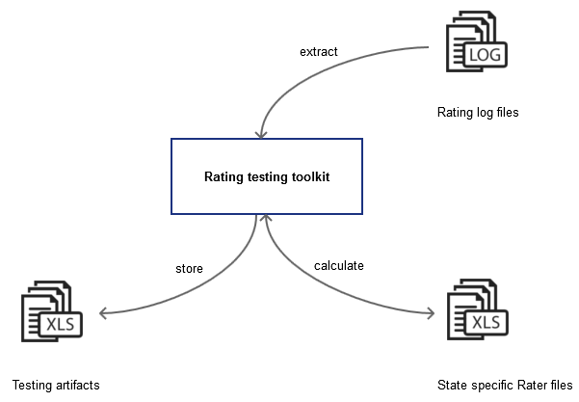

The Rating testing toolkit executes the following actions:

* extract rating request attributes from log files that generated of PAS application;
* prepare data for Rater reference premiums calculation;
* execute premium calculation using Rater reference implementation;
* extract of rating response attributes from log files that generated of PAS application;
* compare rating attributes between different implementations;
* store testing artifacts;

The framework considers state specific behavior of rating reference implementations. The state specific rating reference implementation (Rater file) represents rating algorithm that implemented in Excel file by Design BA team. Each Excel file has a similar structure but only in line of business (Auto, Homeowner).

PAS rating log contains information about PAS rating engine calculation: request data for rating engine premium calculation and results of premium calculation. All data is represented in xml format.

# Project components

The rating testing toolkit consists of the following components:

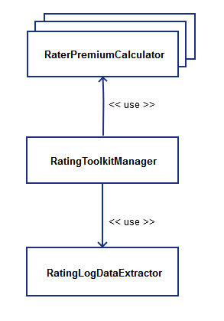

***RatingToolkitManager*** is the main component of rating testing toolkit. It coordinates interaction of other components This rating testing automation framework should use it as entry point.

***RatingLogDataExtractor*** parses rating log file of PAS app to prepare request/response data for reference premium calculation and premium verification.

This component extracts data from aaa-rating-engine-soap.log file that contains the following data:

|  |
| --- |
| **ID: 1** Address: http://localhost:8110/aaa-rating-engine-app/ws/home-ca Encoding: UTF-8 Http-Method: POST Content-Type: text/xml; charset=UTF-8 Headers: {Accept=[*/*], cache-control=[no-cache], connection=[keep-alive], Content-Length=[5940], content-type=[text/xml; charset=UTF-8], host=[localhost:8110], pragma=[no-cache], SOAPAction=[""], user-agent=[Apache CXF 2.7.8]} Payload: <**soap:Envelope xmlns:soap="http://schemas.xmlsoap.org/soap/envelope/"**><**soap:Body**><**ns1:determinePolicyPremium xmlns:ns1="http://ca.home.rating.aaa.exigen.com/"**>...</**ns1:determinePolicyPremium**></**soap:Body**></**soap:Envelope**> -------------------------------------- 18:10:30,266 INFO [http-bio-8110-exec-1]: Outbound Message --------------------------- **ID: 1** Encoding: UTF-8 Content-Type: text/xml Headers: {} Payload: <**soap:Envelope xmlns:soap="http://schemas.xmlsoap.org/soap/envelope/"**><**soap:Body**><**ns1:determinePolicyPremiumResponse xmlns:ns1="http://ca.home.rating.aaa.exigen.com/"**>...</**ns1:determinePolicyPremiumResponse**></**soap:Body**></**soap:Envelope**> |

The data extractor searches pair request/response data by policy number. The pair request/response has the same ID field in this file.

The rating engine request data has information from UI of PAS application, see fragment below:

|  |
| --- |
| <**ns1:arg1 xmlns:ns2="http://ca.home.beans.generated.openl.org"  xmlns:xsi="http://www.w3.org/2001/XMLSchema-instance" xsi:type="ns2:Policy"**>  <**ns2:ageOfOldestInsured**>59</**ns2:ageOfOldestInsured**>  <**ns2:claimPoints**>0</**ns2:claimPoints**>  <**ns2:constructionGroup**>CO1</**ns2:constructionGroup**>  <**ns2:covALimit**>510000.0</**ns2:covALimit**>  <**ns2:covCLimit**>255000.0</**ns2:covCLimit**>  <**ns2:covELimit**>500000.0</**ns2:covELimit**>  <**ns2:coverages**>  <**ns2:Coverage xsi:type="ns2:Coverage"**>  <**ns2:additionalLimitAmount xsi:nil="true"**/>  <**ns2:coverageCd**>CovE</**ns2:coverageCd**>  <**ns2:deductible xsi:nil="true"**/>  <**ns2:deductibleAmount xsi:nil="true"**/>  <**ns2:limit**>500000</**ns2:limit**>  <**ns2:limitAmount**>500000.0</**ns2:limitAmount**>  </**ns2:Coverage**>  </**ns2:coverages**>  <**ns2:deductible**>250.0</**ns2:deductible**>  <**ns2:dwelling xsi:type="ns2:Dwelling"**>  <**ns2:address xsi:type="ns2:Address"**>  <**ns2:zipCode**>90210</**ns2:zipCode**>  </**ns2:address**>  <**ns2:ageOfHome**>5</**ns2:ageOfHome**>  <**ns2:brushFireZone**>false</**ns2:brushFireZone**>  <**ns2:burglarAlarmType**>None</**ns2:burglarAlarmType**>  <**ns2:constructionType**>Superior</**ns2:constructionType**>  <**ns2:fireAlarmType**>None</**ns2:fireAlarmType**>  <**ns2:foundationType**>Raised</**ns2:foundationType**>  <**ns2:hasSprinklers**>false</**ns2:hasSprinklers**>  <**ns2:hasWoodStove**>false</**ns2:hasWoodStove**>  <**ns2:isGatedCommunity**>false</**ns2:isGatedCommunity**>  <**ns2:isSecondaryHome**>false</**ns2:isSecondaryHome**>  <**ns2:numOfFamilies**>1</**ns2:numOfFamilies**>  <**ns2:numOfLivestock**>0</**ns2:numOfLivestock**>  <**ns2:numOfStories**>1.0</**ns2:numOfStories**>  <**ns2:ppcValue**>5</**ns2:ppcValue**>  <**ns2:roofType**>Metal</**ns2:roofType**>  <**ns2:swimmingPoolType**>None</**ns2:swimmingPoolType**>  <**ns2:yearsSinceRenovation**>1000</**ns2:yearsSinceRenovation**>  </**ns2:dwelling**>  <**ns2:expClaimPoints**>0</**ns2:expClaimPoints**>  <**ns2:forms**>  <**ns2:Form xsi:type="ns2:Form"**>  <**ns2:applyDiscounts**>true</**ns2:applyDiscounts**>  <**ns2:formCode**>HO-90</**ns2:formCode**>  <**ns2:formOid**>vv6e98RFCd5tc_DEjxdBqw</**ns2:formOid**>  <**ns2:hasSupportingForm**>false</**ns2:hasSupportingForm**>  <**ns2:numOfFamilies**>1</**ns2:numOfFamilies**>  </**ns2:Form**>  </**ns2:forms**>  <**ns2:frequencyOfDwellingLoss**>0.0</**ns2:frequencyOfDwellingLoss**>  <**ns2:hasAutoPolicy**>false</**ns2:hasAutoPolicy**>  <**ns2:hasCeaPolicy**>false</**ns2:hasCeaPolicy**>  <**ns2:hasEmployeeDiscount**>false</**ns2:hasEmployeeDiscount**>  <**ns2:hasMultiPolicyDiscount**>false</**ns2:hasMultiPolicyDiscount**>  <**ns2:hasPolicySupportingForm**>false</**ns2:hasPolicySupportingForm**>  <**ns2:hasSeniorDiscount**>false</**ns2:hasSeniorDiscount**>  <**ns2:isAaaMember**>true</**ns2:isAaaMember**>  <**ns2:isNewLoan**>false</**ns2:isNewLoan**>  <**ns2:isRented**>false</**ns2:isRented**>  <**ns2:occupancyType**>Owner</**ns2:occupancyType**>  <**ns2:occupation**>None</**ns2:occupation**>  <**ns2:policyNumber**>**QCAHO900014488**</**ns2:policyNumber**>  <**ns2:yearsOfPriorInsurance**>0</**ns2:yearsOfPriorInsurance**>  <**ns2:yearsOwned**>0</**ns2:yearsOwned**>  <**ns2:yearsSinceLoan**>0</**ns2:yearsSinceLoan**>  <**ns2:yearsWithCsaa**>0</**ns2:yearsWithCsaa**> </**ns1:arg1**> |

The request/response information is transformed to data structure to use for premium calculation in RatingPremiumCalculator components.

***RatingPremiumCalculator*** components are state specific executors of reference rating algorithms (Rater Excel file).

The reference rating algorithms can be found in “Batch Rater” sheet of each state specific Rater file:

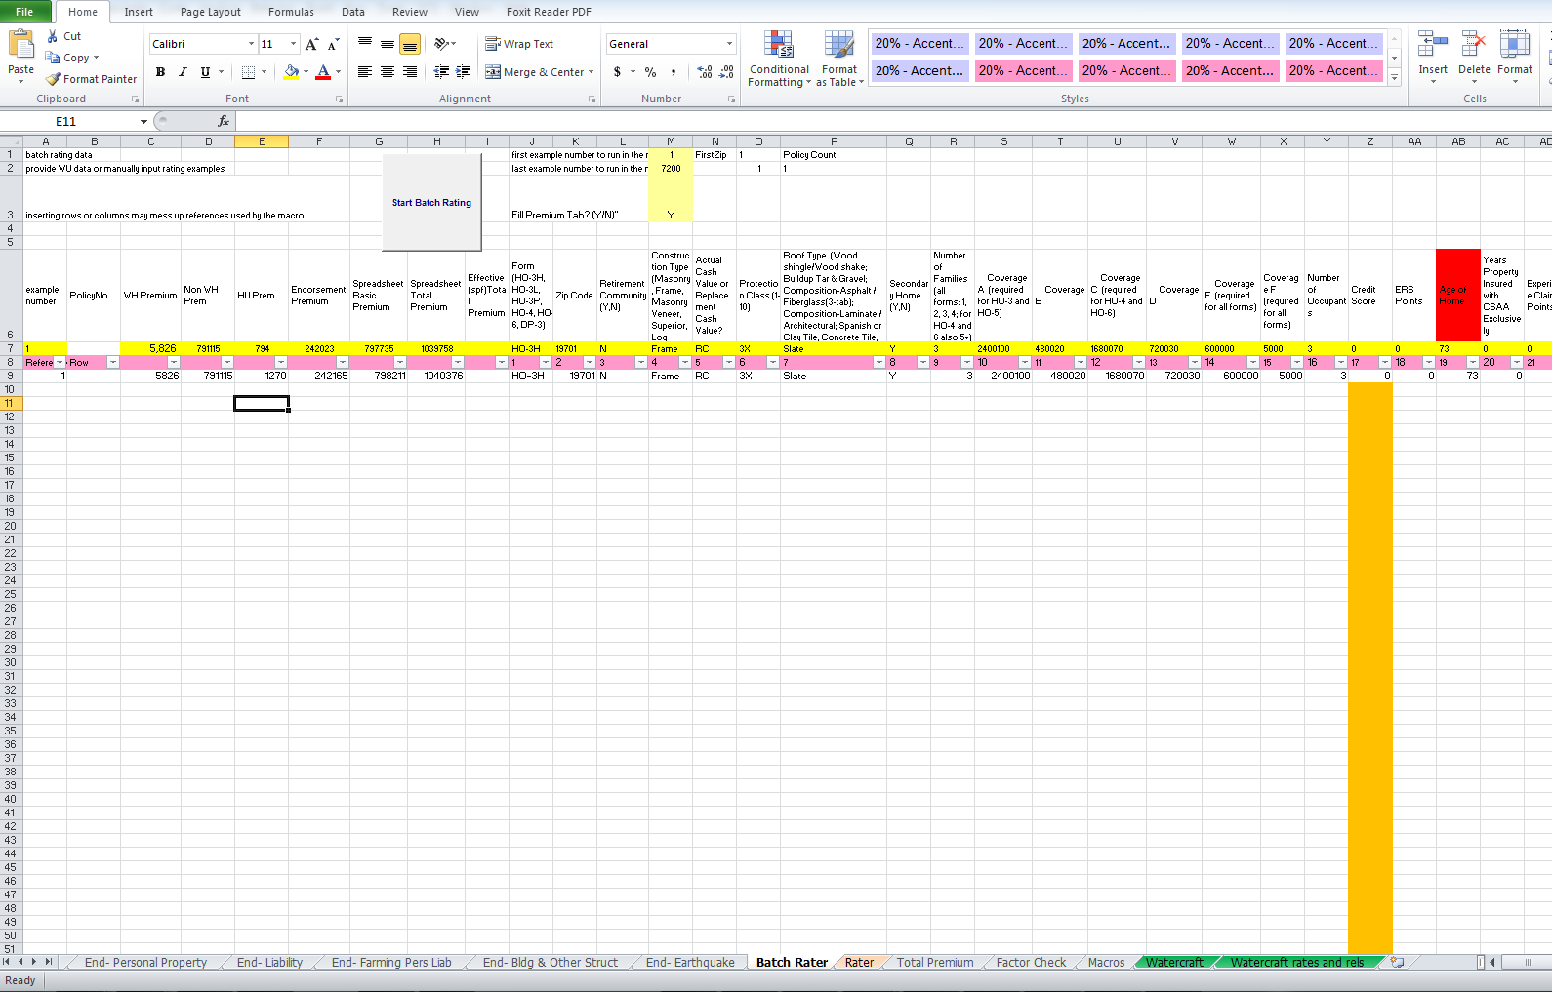

# Calculator components fill this sheet using state specific mapping file (MappingConfig.xlsx) that stores information about mapping data from rating log and cell in “Batch Rater” sheet (reference implementation or rating algorithm).

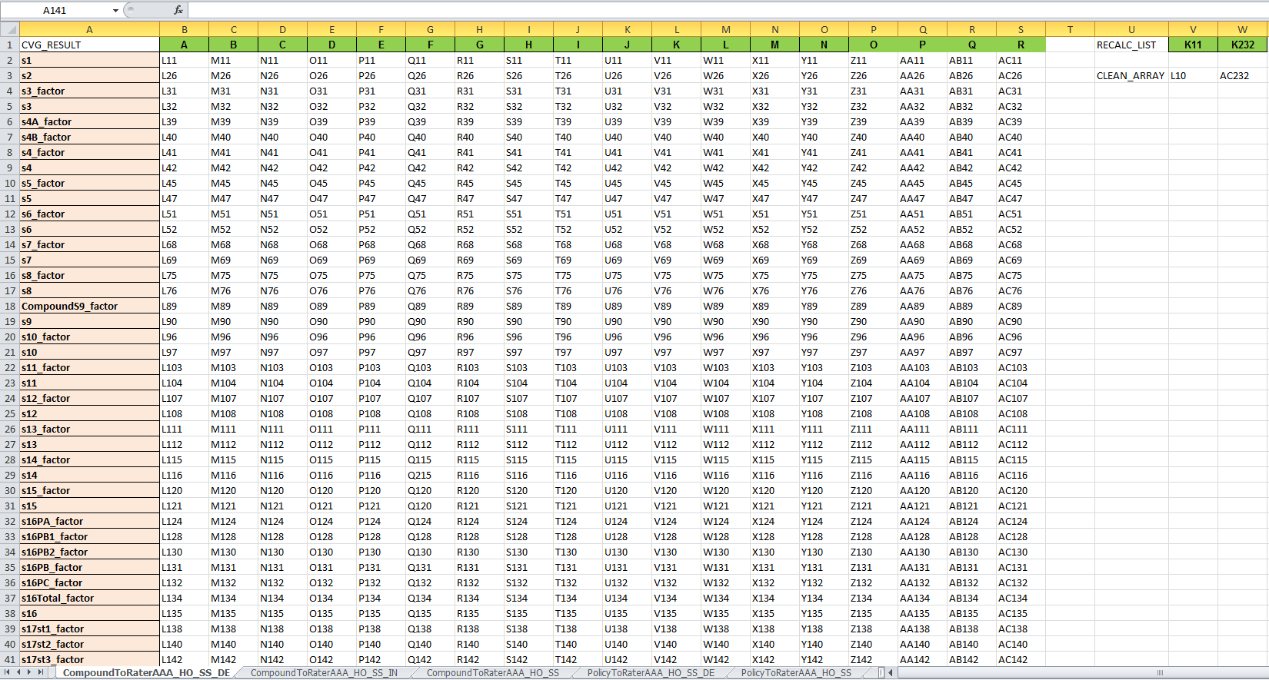

# State specific calculator executes reference rating state specific algorithm using Apache POI ([the Java API for Microsoft Documents](http://poi.apache.org/)).

Premium calculation results will be placed on “Rater” sheet.

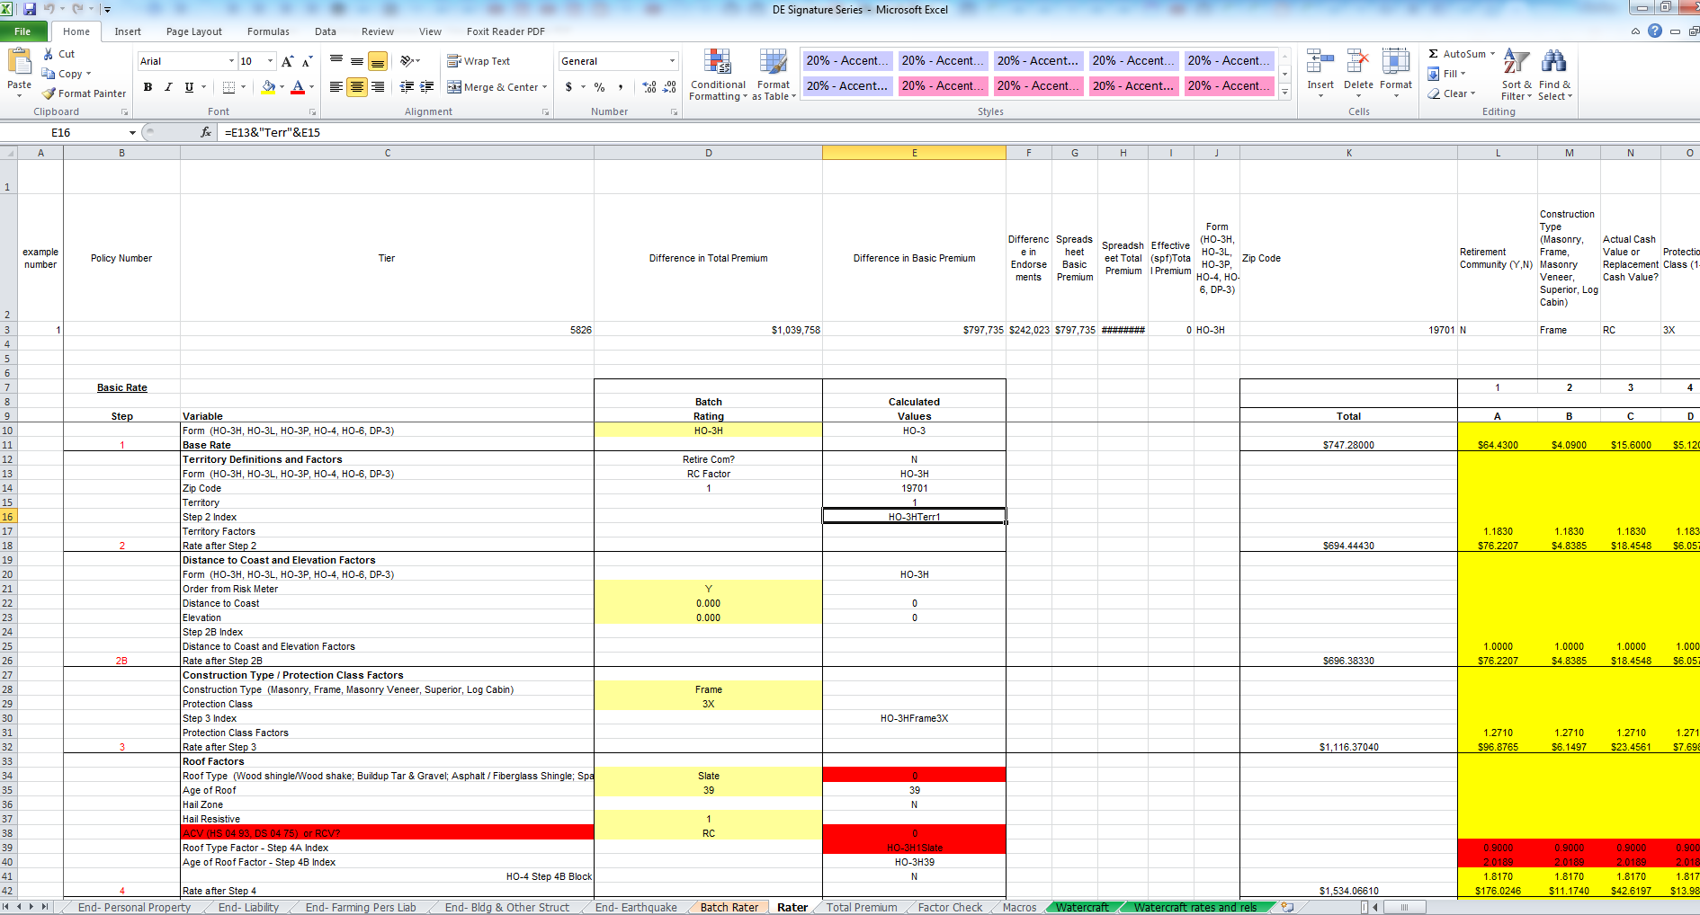

Also ***RatingPremiumCalculator*** creates new “Rating result” sheet and place premium calculation result from rating log (PAS rating engine results) with the same structure like “Rater” sheet (rater reference algorithm) and verifies rating attributes by cells.

If rating attributes from “Rating result” sheet (rating engine) are different from “Rating” sheet (rater reference algorithm) it’ll be marked red color for addition manually analysis by QA side.

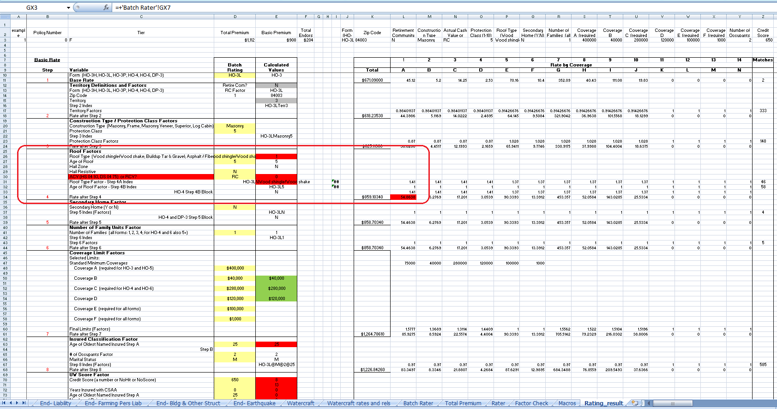

## Project packaging and configuration

Rating testing toolkit is placed in 2 packages:

* ***toolkit.ratingtest*** - contains general code
* ***toolkit.ratingtest.impl*** - contains code, that is specific for different products and states
* ***toolkit/ratingtest*** – contains state specific Rater reference algorithms files and mapping (MappingConfig.xlsx) file.

|  |  |
| --- | --- |
|  |  |

.